**Dear CHA Member,**

**Thank you for being part of this!**

Our members truly came through for us in the last year and we are really looking forward to having you be part of our Association in 2021!

**This year was filled with hope, success, and improvements because of you. We feared that being forced to limit access to the shelter during the pandemic would make adoptions difficult. However, we took in and rehomed similar numbers of pets this year to the past year and made some much-needed updates to the shelter building.**

***With your support, we saved them:***

**Paula Scuttle Pearl Cletus**

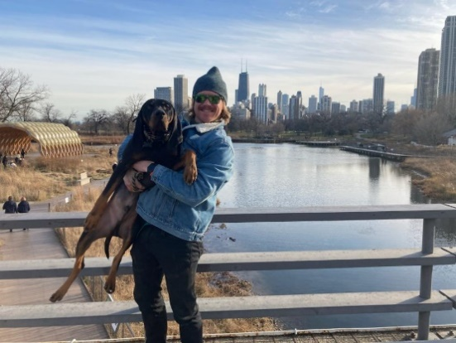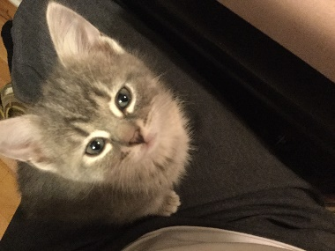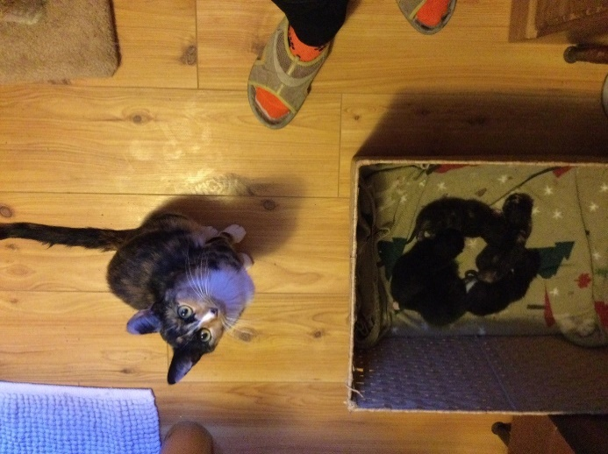

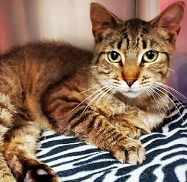 ***Paula just Two year old Pearl and her 5***

***returned to the Scuttle weighed siblings were***

***shelter after only 6 lbs when adopted quickly***

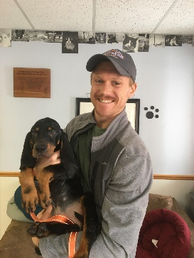 ***raising 5 kittens he arrived and into their new***

***in foster care. is now a healthy homes last fall.***

***She is snuggly 10 lbs. He is***

***and needs her FIV + and still***

***forever home. needs a home.***

*Cletus arrived as the result of a neglect case and went to a great home in Illinois*

*where he has grown from a pup to a beautiful hound dog!*

**We ask that you** **renew your membership today!**

**Members receive a quarterly newsletter with shelter updates, heart-warming adoption stories, and helpful pet tips. Members also may attend and contribute to the shelter’s board meetings, serve on board committees, receive** invitations to major events, receive 5 free door prize tickets at the Purr and Paw Dinner and Dog Walk events, and receive adoption discounts. Most importantly, your membership fees help us to keep doing the important work of rescuing homeless animals in the community.

**With your membership we achieved a great deal:**

* **We replaced the worn-out window coverings and access doors in our dog run.**
* **We secured enough funding in our emergency veterinary fund to remove the damaged eyes of 9 kittens, complete a hernia repair, and do a couple of tail amputations required due to severe injuries.**
* **We spayed and neutered hundreds of homeless animals.**
* **We completed repairs to roof snow breaks and gutters resulting from past record snowfalls.**
* **We replaced our dryers and our septic system which were quite worn out.**

We are so thankful for our members who support our shelter. Please join us again this year and renew your membership online (<http://www.chippewahumane.com/>) or with the form on the back of this letter.

Also watch our website for information and ticket sales for our Purr and Paw Murder Mystery Dinner. We will be setting a summer date as soon as we have more information about the pandemic. Thank you for your contributions and we look forward to your renewed membership for 2021!!

****Sincerely,

**Deb Newman**

**Chippewa Humane Association Board President**

**(over)**

**I choose families and pet health for 2021!!**

NAME: _______________________________________

ADDRESS: ____________________________________

CITY: _________________________STATE_________

ZIP CODE: _____________________ **Yosemite**

and

PHONE: _______________________ **Chata** thank you!

EMAIL: _______________________________ (we do not sell e-mails and are offering e-news to our members)

TYPE OF MEMBERSHIP:

_____ SENIOR ($25) **Please make check payable and send to:**

_____ INDIVIDUAL ($30) Chippewa Humane Association

_____ FAMILY ($50) PO Box 562

_____ PATRON ($100) Chippewa Falls, WI 54729

_____ OTHER ($___________) (or use convenient credit card option below)

I want to contribute additional funds to help the animals:

____ $10 ____ $25 ____ $50 ____ $100 ($__________) Other

IN HONOR OF______________________________ or IN MEMORY OF__________________________________

____ Please check if you wish your donation to be anonymous.

____ Please check here if you have an interest in serving on a board committee (i.e. fundraising, murder mystery dinner, newsletter, etc.).

----------------------------------------------------------------------------------------------------------------------------------------------------------

❒ **Credit Card Payment** (fill in information below)

Visa   Discover MasterCard  Account # ___________________________________________

Expiration Date ____________ CVC (3 digit security code) __________

Card Holder Printed Name ______________________________________

Card Holder Signature _________________________________________

You can also visit our website <http://www.chippewahumane.com/>.   1/21

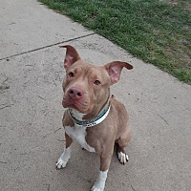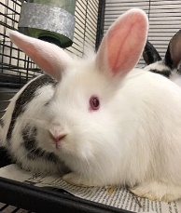

**Thank you for your membership!**

**If you wish to contact members of the Board of Directors, you may e-mail us at** [board@chippewahumane.com](mailto:board@chippewahumane.com)

\*\***Members are eligible to join the Board of Directors, Shelter Committee, and other outreach committees. **Members receive CHA’s quarterly Shelter Friends Newsletter.**

**\*\*Members receive special invitations to fundraising and outreach events.**

**\*\*Members receive five free door prize tickets when attending the Purr and Paw Dinner and Dog Walk.**

**\*\*Members receive an adoption discount.**

**The Chippewa Humane Association is not affiliated with any national organization (i.e. HSUS). We are entirely independent in our operation.**

***Your continued support is appreciated and essential. Be a voice for those who cannot speak!***